**Lab Manual- Create VM on Azure Portal**

**Prepared for**:

**Date:** 18th Nov 2018

**Prepared by:** Aditi Shrivastava

Document Name: Lab Manual

**Document Number** SysOpsLab316

**Contributor:**

Table of Contents

1 OBJECTIVE 3

2 VM Sizes 3

3 PRE-REQUISISTE 4

4 Creating Azure Virtual machine in Azure Portal 4

# OBJECTIVE

Azure Virtual machine will let us create and use virtual machines in the cloud as Infrastructure as a Service. We can use an image provided by Azure, or partner, or we can use our own to create the virtual machine.

Virtual machines can be created and managed using:

* Azure Portal
* Azure PowerShell
* ARM templates
* Azure CLI

Following are the configuration choices that Azure offers while creating a Virtual Machine.

* Operating system (Windows and Linux)
* VM size, which determines factors such as processing power, how many disks we attach etc.
* The region where VM will be hosted
* VM extension, which gives additional capabilities such as running anti-virus etc.
* Compute, Networking, and Storage elements will be created during the provisioning of the virtual machine.

# VM Sizes

It is important to select the right VM size and type for the working of our virtual machine perfectly. So, these are the VM sizes that are available within Azure.

|  |  |  |
| --- | --- | --- |
| **Type** | **Sizes** | **Description** |
| General-purpose | B, Dsv3, Dv3, DSv2, Dv2, DS, D, Av2, A0-7 | It has balanced CPU-to -memory ratio, It is ideal for testing and development, small to medium databases, and low to medium traffic web servers. |
| Compute-optimized | Fsv2, Fs, F | It has a high CPU-to-memory ratio. It is suitable for medium traffic web servers, network appliances, batch processes. |
| Memory-optimized | Esv3, Ev3, M, GS, G, DSv2, DS, Dv2, D | Is has a high memory-to-CPU ratio. Great for relational database servers, medium to large caches, and in-memory analytics. |
| Storage optimized | Ls | It has high disk throughput and IO that is Ideal for Big Data, SQL, and NoSQL databases. |
| GPU | NV, NC, NCv2, ND | It is a specialized virtual machine that is targeted for heavy graphic rendering and video editing. Available with single or multiple GPUs. |
| High performance compute | H, A8-11 | It is the fastest and most powerful CPU virtual machine with optional high-throughput network interfaces (RDMA). |

# PRE-REQUISISTE

* Accounts in Azure
* A local Computer with 4 CPU, 16 GB RAM, 200 GB disk space

# Creating Azure Virtual machine in Azure Portal

**Step 1:** Click on All services and then click on the Virtual machine button, as shown in the following image.

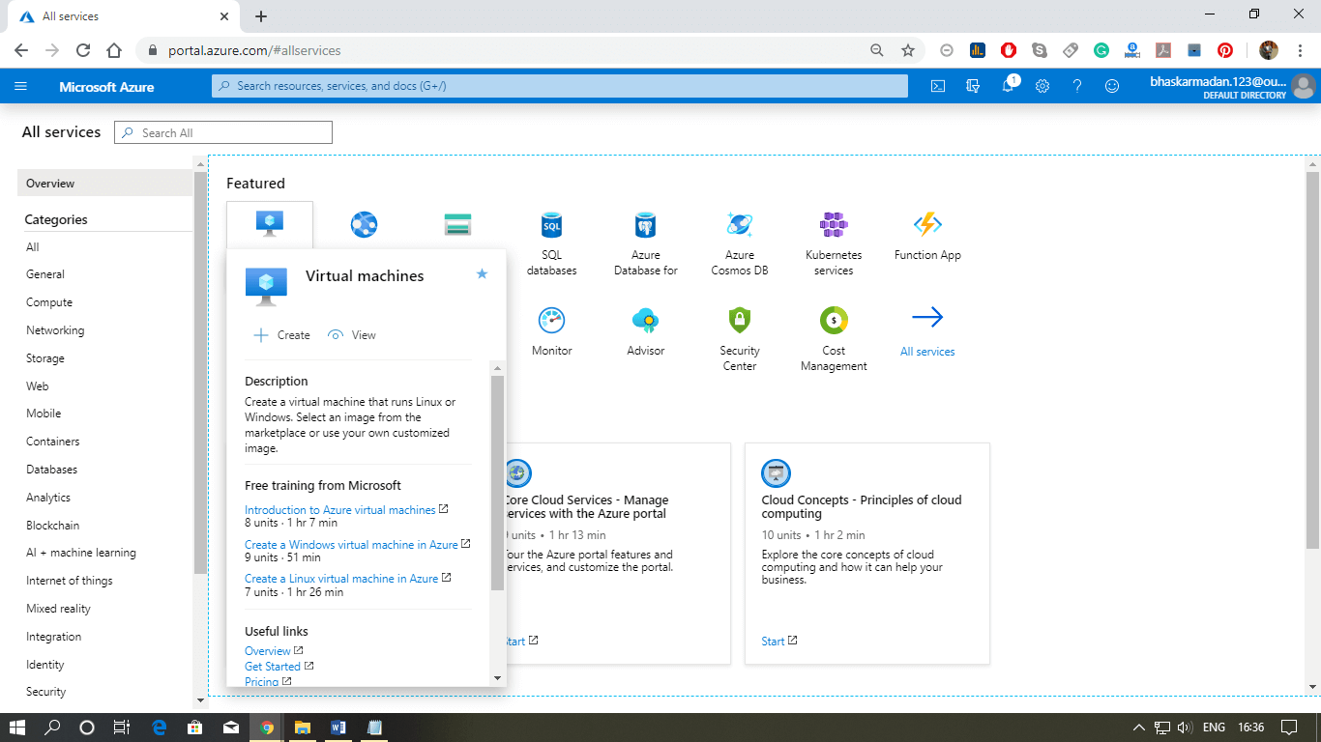

**Step 2:** Click on create, then you will be redirected to the Create Virtual machine page.

Choose your Resource Group : Aditi

Type the VM Name : DemoVM

Choose the VM Image = Windows Server 2016

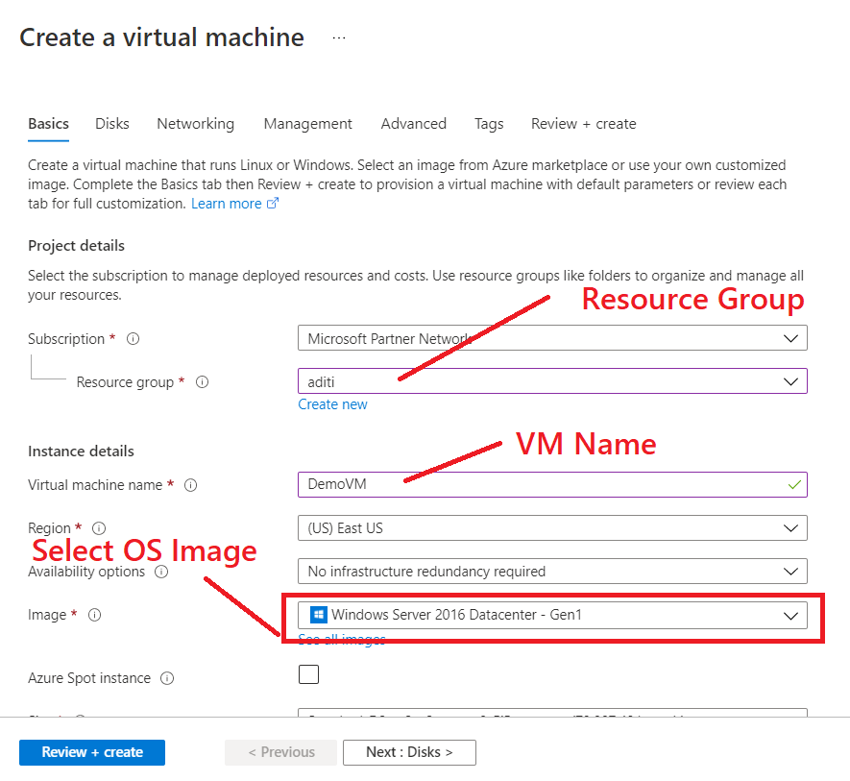

**Step 3:** After selecting the image as Windows Server 2016 Now select the size and type of VM according to your requirements.

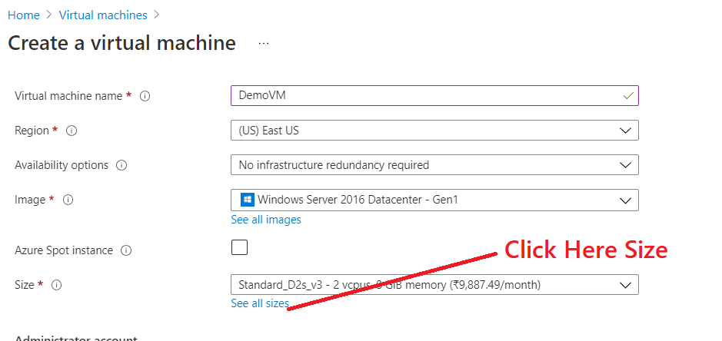

**Step 4:** Select B1MS and click **Select**

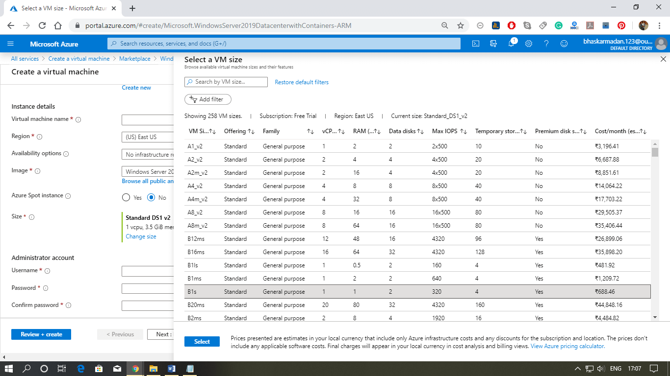

**Step 4:** After that, set a User name and password for your Virtual Machine then click next.

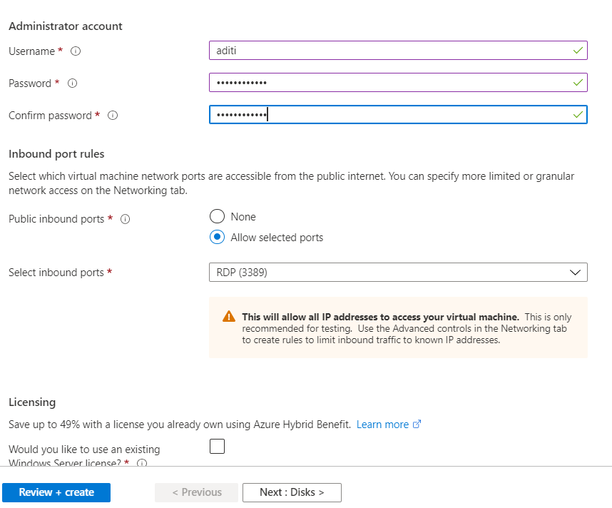

**Step 6:** You are on the disk tab now, Select the disk type you need then click next to redirect on the networking page.

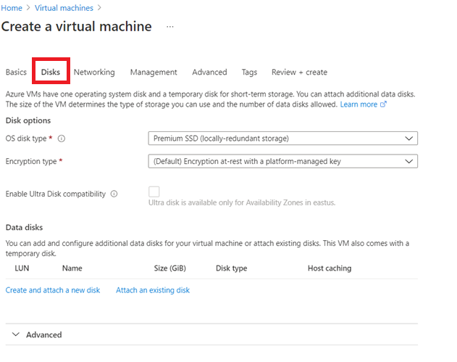

**Step 7:**Select the virtual network, subnet, and IP address for the Virtual machine. We are leaving it as default because we are creating it for the training purpose.

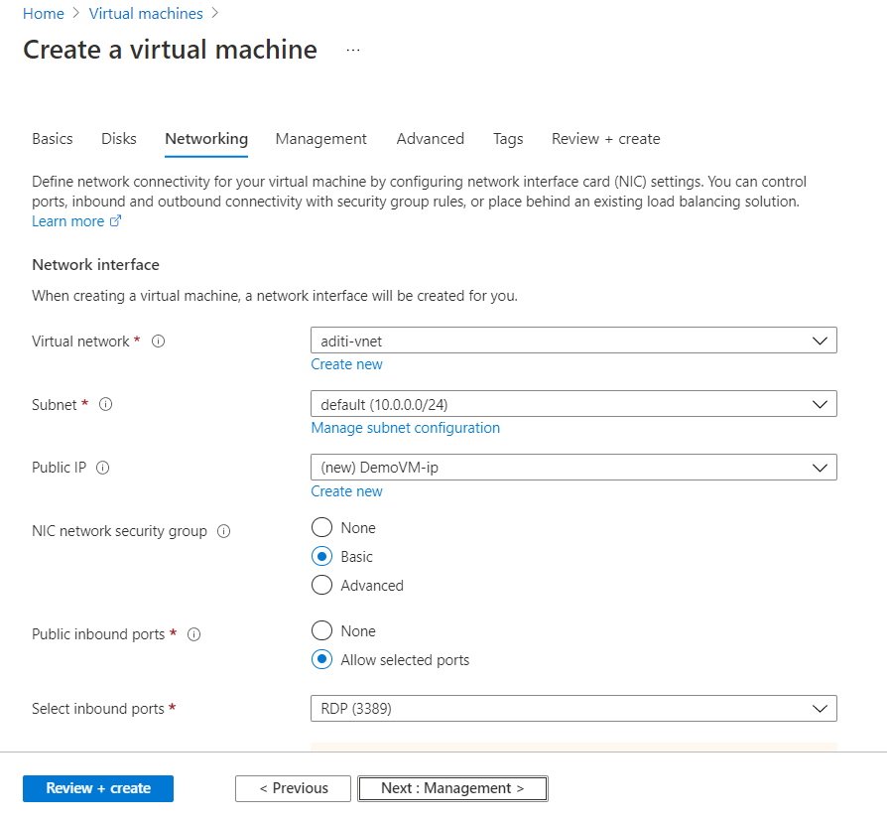

**Step 8:**Now select the management tab, and click next.

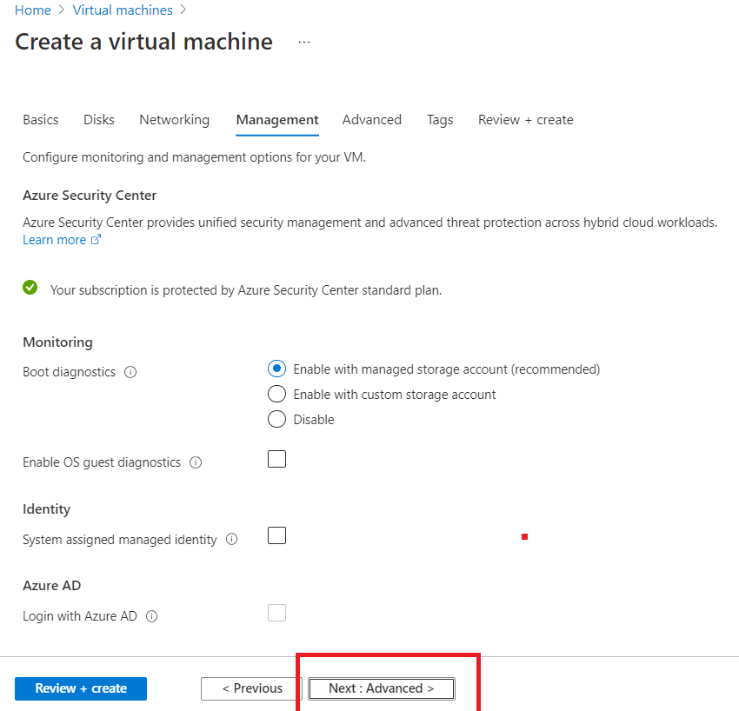

**Step 9:**In advanced settings, you can embed an extension to the virtual machine but leave everything as default and click **Next**

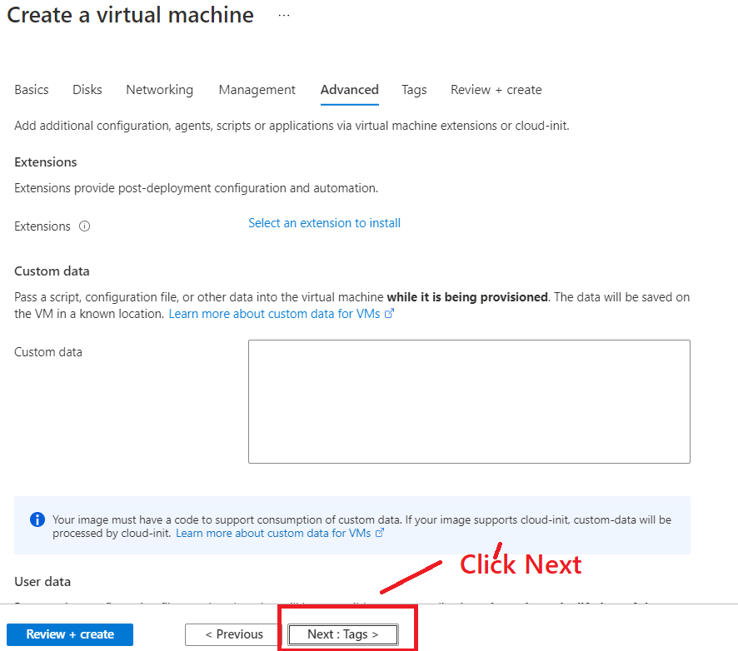

**Step 10:** Leave the tag default and cliek next

**Step 10:** Now, on the review and create a window, click on the create button

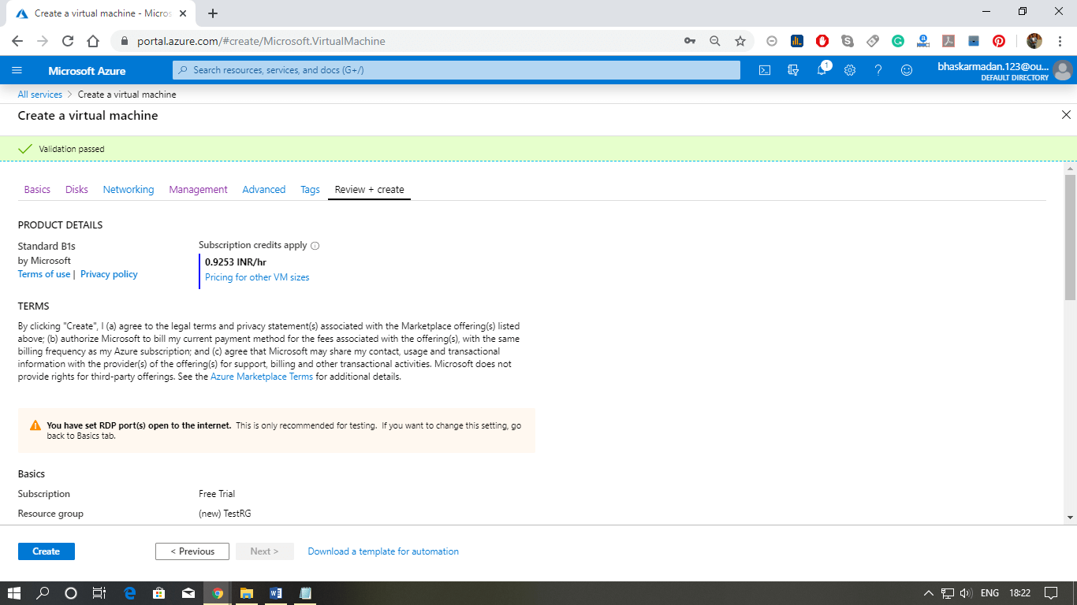

**Step 11:** Now, on the review and create a window, click on the create button

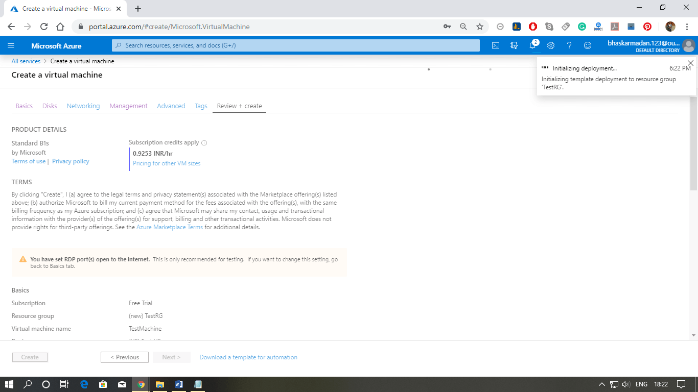

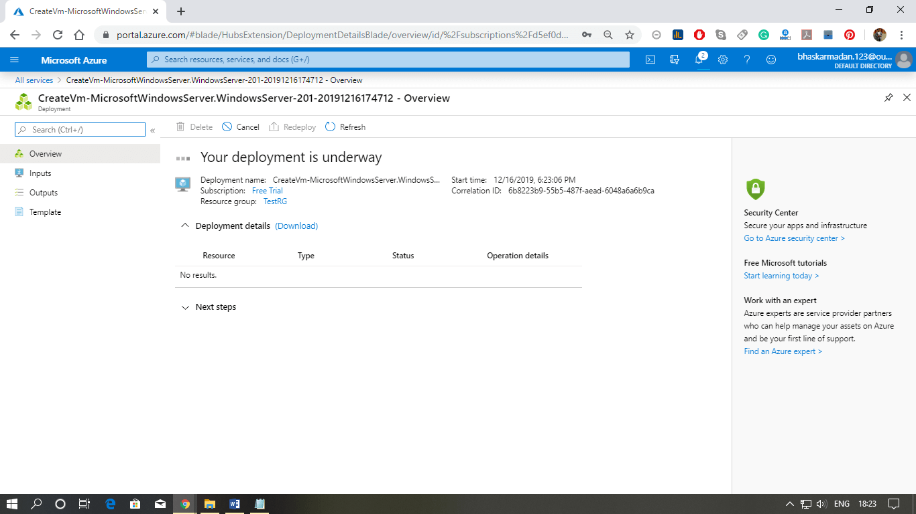

When your Virtual Machine is created, the following window will appear. You can now use your virtual machine.

